switches are used as transit devices.
switches used in this course are MLS switches.
2960 are layer 2 switches.
PT and 3560-24PS are multilayer switches.

In this course, switches used are 2900 series, 3500 series, and 3600 series.

Console cable is used to configure router.

Fixed routers are those routers which comes with fixed cards/slots. 2500. 800 series are fixed routers.

Modular routers can be extended with different cards as they come with extra slots.
1700, 1600, 2600, 2800, 3600, 3700 are modular router series.

Serial Ports: used for WAN connectivity. For example you have two LANS; LAN A is in Ireland, and LAN B is in London. You can use serial cable to connect these routers.

Fast Ethernet ports are used to connect LAN connections.

Console port: Console port, BTY port (logical port) are called admin ports. These ports are used to manage or configure routers. Hyper Terminal software is used to configure router.
TELNET and SSH are used to gain remote access to router.

When the router starts, it will do a self-test. These components are listed below:
1) Post: Power on self test checks the hardware
2) ROM: Loads the bootstrap programs and searches for the IOS (Flash/TFTP/ROM)
3)Flash: stores IOS
4) NVRAM (Non Volatile Memory): stores configurations permanently. Startup Configure

Cisco Hierarchy: Enterprise networks are configured in three layers:

Core Layer, Distribution/aggregation Layer, Access Layer.

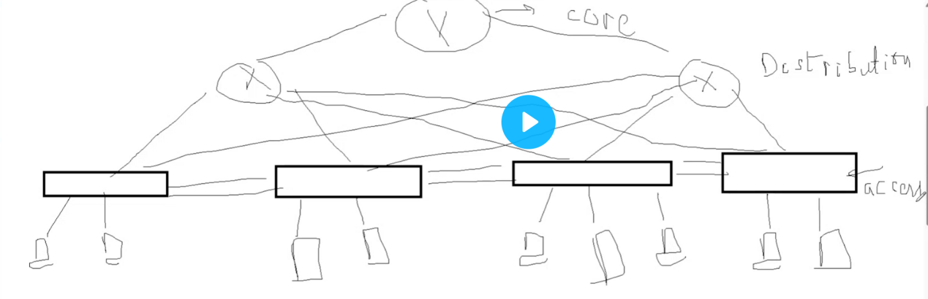

STP: Spanning Tree Protocol.
Layer 2 Protocol.

Layer 2 Switch Main cable Layer 2 Switch
Redundant

Redundant bit is down under normal situation. In case of failure of the main cable, the traffic will be directed via redundant cable.
STP is IEEE 802.1D
STP is enabled by default on Cisco Catalyst (Layer-2) switches.
If STP is not enabled, a loop will be created between these two switches. If a loop is created, you don’t get any error messages and is really hard to troubleshoot.

STP works on the following considerations:
- Select the root Bridge
- Select the Root Port
- Select the designated port and non designated port.

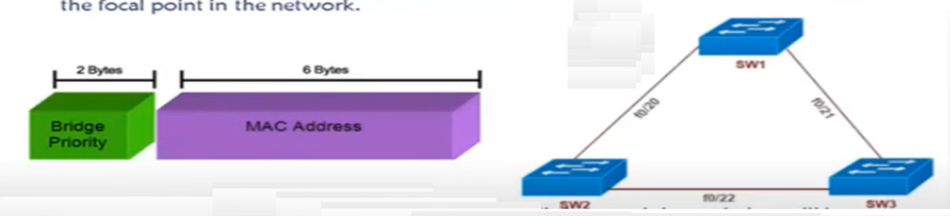

To select the root bridge, choose the bridge (Switch) which has the lowest Bridge ID.
Bridge ID = Priority +MAC address of the switch.

Default priority of each switch is 32768
If the priority is the same, then the switch with least MAC address will become the root bridge.
So to make a switch root bridge, choose the switch with lowest MAC address or lower down the priority. Lower the priority number, higher the priority will be. Example, Priority 8192 priority will become a root bridge instead of switch having a priority 32768.
The range of priority is from 0 to 61440 but the value must be in the increment of 4096.

Dynamic Routing:
- Distance Vector (Routing Information Protocol -RIP) OPEN standard protocol. Can run on CISCO, JUNPER, HUAWEI routers. It is classful protocol which means it doesn’t not understand subnetting. It will always take networks in default subnets such as /8, /16 / 24 /32 only. RIP Updates on RIPv1255.255.255.255.255. RIPv2 sends its updates on IP 224.0.0.9
Metric: Hop count
Max routers: 16
RIP AD: 120
RIP has bad timers
Update timer is 30 sec, hold down is 180 sec, out is 240 sec..

- EIGRP: EIGRP consider the following in order to choose the best path:
Bandwidth, Delay, Reliablitiy, Load, MTU. Therse are also called “K”s.
The formula is EIGRP metric = 256 slowest
- Link State (OSPF IS-IS)

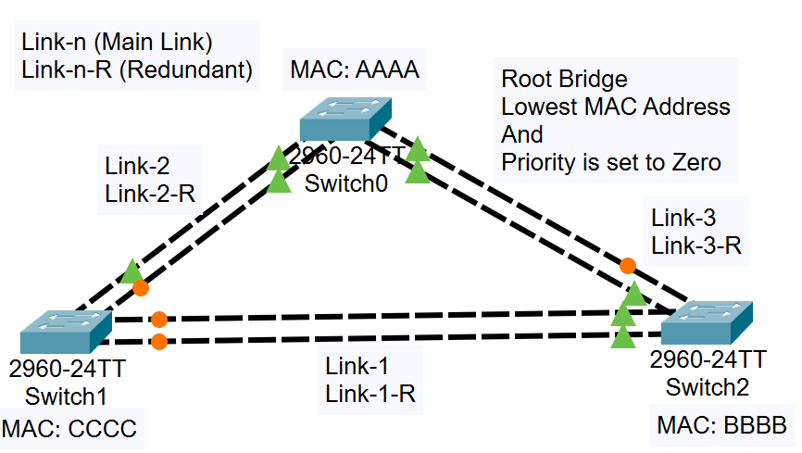

In this kind of situation, we need to select a root port which is the shortest path from that switch towards the root bridge (Switch0). The root port (shortest path to root bridge) of Switch1 is Link-2 and the root port of Switch2 is Link-3. But If you see Switch1 and Switch2 are unable to communicate directly with each other via Link-1. in both cases (Switch1 sending traffic to Switch2 or Vice Versa), the traffic must pass by the root bridge. This was discussed before as the limitation of STP as you can clearly see that the shortest path between Switch1 and Switch2 is Link-1 but they are unable to use due to STP Protocol.

- What is the difference between Root Port, Forward Port, Designated Port, and Altenrate Port?
- Why the ports on switch1 via link-1 are orange and on switch2 both are green?

Port Cost:
Link Speed (Bandwidth) | Port Cost | Connection Type
10 Mbps | 100 | Ethernet
100 Mbps | 19 | Fast Ethernet
1 Gbps | 4 | ????
10 Gbps | 2 | ????
- What is the connection type of 1 Gbps and 10 Gbps?

States (Stages) of a port:
- Listening State (Amber colour): The port will remain in listening state for 15 seconds.
- Learning State: The port will remain in learning state for 15 seconds.
So BPDU time + Listening State time + Learning State time (20+15+15) = 50 seconds delay. This means STP will wait for 50 seconds each time a new switch is installed.
- When we install a new switch, why would STP needs to wait for BPDU since there was no switch there before. If installing a new switch, technincally, it should wait for 30 seconds (listening and learning state). Why is it waiting for BPDU?

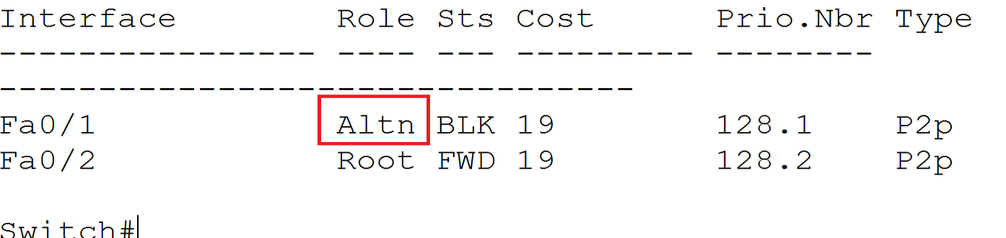

- If both ports are in Desg state, then that’s the root bridge. But what about the following states? One is Desg and other is Root
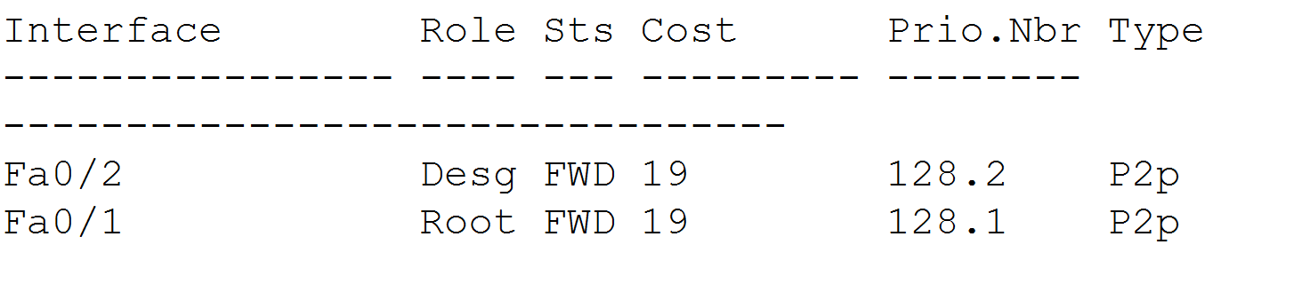

Designated Port is selected on basis of the following aspects:
- Least cost (speed) (Port Cost)
- The Lowest forwarding switch ID/Bridge ID (Priority + MAC address)
- Lowest forwarding physical Port Number (Ethernet port). You did not explain this point.

The warning message clearly depicts that PortFast should only be configured on ports connected to single hosts which can be a PC, Laptop, or Printer. PortFast should not be configured on a switch, hub or any device which has multiple links otherwise it will create a loop. The idea of non-trunking mode is discussed in further sections. Also, if you enable PortFast on FastEthernet 0/7 and FastEthernet 0/8, STP will stop only on these ports. You will still face the delay (amber colour for 30 or 50 sec) on all other ports.
- Do we need to configure portfast on each port one by one? It is time consuming. How often is it practised and is it important to configure portfast?

- Is Alternate port always the Block Port? Also, is it always the Alternate Port (Block Port) who will become the root port upon failure of the primary link?

- What is the reason we are not supposed to configure uplink fast on the root bridge?
- Is Uplink Fast feature available only on Cisco switches?

Commands to activate backbone fast and uplink fast.
- Should we configure uplink fast (If RSTP is not ideal) and backbone fast on the entire switch or on a specific port number?

- In case of UplinkFast, we are skipping the wait time. Will it not create a time conflict or any other disadvantage? What if the switch is not down but there’s a two or three seconds dalay? In such case, UplinkFast will think the switch is down while it is not. Also, if there’s no negative consequences of UplinkFast but has the “delay skipping” advantage, why the switch doesn’t come with UplinkFast (If we had the opportunity to stop UplinkFast on the root bridge because we shouldn’t configure UplinkFast on the root Bridge) or BackboneFast by default?

- What if we configure Backbone on every switch (which will skip 20 seconds delay) and then configure

- UplinkFast on every Non-Root Switch. By dong so, we can bring 50 seconds delay to 2 or three seconds.
- You said Edge Port in RSTP is the same as PortFast in STP. But at the same time, you said there’s a little difference. What is the difference? You didn’t explain.

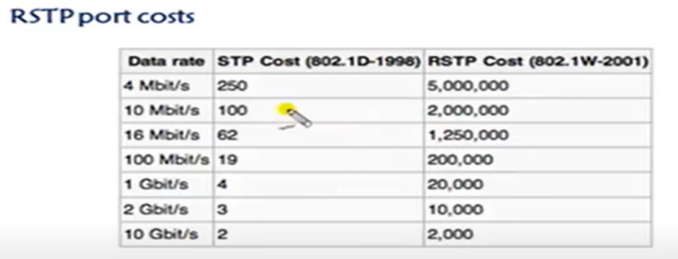

As we know RSTP enables uplink fast, backbone fast and port fast on each switch. But you said we should never configure Uplink fast on the root bridge. By enabling RSTP, the will Uplink fast not be enabled on the root bridge?
- What makes RSTP cost different than STP cost?

However, EtherChannel logical combination is limited to 8 links. EtherChannel can be layer2 or can be layer3 and the port channel is the logical instances of the physical link.
- What is mean by “Port Channel is the logical instances of the physical link”? Is there any difference between EtherChannel and Port Channel?

- In types, we discussed two types: Manual configuration and using Protocols. What is mean by manual configuration and how can we do it? Is there any advantage of one over another?

Keep in mind that if you configure Auto on Switch A and B both, then EtherChannel will not be established because in Auto mode, both switches are waiting for a proposal and both of them will receive nothing. While in Auto - Desirable mode, Desirable will send a proposal and Auto mode is waiting to receive the proposal and hence the connection will be made. The same scenario applies to passive - passive or active - active.
This is shown in the following table:
Switch A Mode | Switch B Mode | Connection Made?
Auto | Auto | No
Passive | Passive | No
Active | Active | No
Auto | Desirable | Yes
Active | Passive | Yes

- Is there any opposite to “ON” like Passive for Active?

Sadia will discuss OSPF IS-IS protocol
Sadia will discuss wildcard mask. She will explain ACL with a case study and will configure Wildcard mask in it.

Transparent mode switch in Virtual Trunking Protocol (VTP):
When a switch with a higher revision number joins the network, it assumes that its configuration is the most up-to-date and attempts to propagate its VLAN information to other switches in the VTP domain.
You mentioned that you experienced this situation at HBL network which will have potentially wiped out all the VLANs in VTP server. What did you do to resolve the issue? Is there any shortcut way to revert all the overrides or you can only do this by uploading the configuration backup or configure manually?

EtherChannel confiuration: How do I assign IPs to PCs since we have configured two different networks on each switch if we have three switches. Lets assume we have switch1, switch2, and switch3. One network between switch1 and switch2. One between switch1 and switch3. Then between switch2 and switch3.

In case of default route, I understand that any packet destined for a network which is not in a stub router’s routing table, will forward it to the next hop. But why Router0 will catch a packet from the internet? Also, the sender from a remote location doesn’t need the stub router’s IP address. Why the stub router will think that a packet is destined for a network in its WAN when he doesn’t even know that what are the other networks connected in its WAN? Stub router will only have directly connected routing table. My question is not based on how and where a stub router will send traffic, but why a stub router will catch traffic from the internet?
First of all, stub router’s routing table will have all router’s ip addresses in its routing table table. Default route is only configured for unknown traffic which means the target device is not in its routing table and therefore, it will handle it to ISP Gateway. The packet is already marked with layer3 header and wherever on the internet, the intended device (or network on the receiving side) sees the packet, they will take it. We must configure static or dynamic route along with default route on stub router otherwise, the stub router will not accept any traffic intended for a network which is not directly connected to it. See the following questions and chat GPT Reponses to get a clear picture of the argument.

By using the command "Ip route 0.0.0.0 0.0.0.0 1.1.1.2", I understand that if the stub router recieves traffic for any destination, forward it to the next hop.
now let's take an example in which I have 4 routers. the first router is configured for default route. now if some over the internet wants to send a packet to my device which is connected to switch 4 and switch 4 is connected with router 4. So how does the stub router knows that there is a router named router 4 which has the following device connected? as you know stub router is only aware of it's next hop
ChatGPT
In a typical network setup involving multiple routers, each router should have a way to learn the routes to different networks. Here’s a simplified explanation of how routing works in such a scenario:

Network Setup Example
Let's assume the following network setup with 4 routers:

Router 1 (R1): Connected to the internet and configured with a default route.
Router 2 (R2): Connected to Router 1.
Router 3 (R3): Connected to Router 2.
Router 4 (R4): Connected to Router 3 and a local switch (Switch 4) with a device.
Routing Process
Default Route Configuration on R1:

R1 has a default route pointing to its next-hop router (e.g., ip route 0.0.0.0 0.0.0.0 1.1.1.2).
Static Routes or Dynamic Routing Protocol:

To ensure that each router knows how to reach the networks connected to other routers, you can use static routes or a dynamic routing protocol (e.g., OSPF, EIGRP, RIP).
Using Static Routes
Each router is manually configured with routes to the networks it needs to reach. For instance:

R4 would have routes to the networks connected to it, but typically doesn’t need static routes for networks directly connected to its interfaces.

Using Dynamic Routing Protocol
A more scalable approach is to use a dynamic routing protocol, which allows routers to automatically share information about networks they can reach.

Routing Packet to the Device
When a packet arrives at R1 destined for the device on Switch 4 (say IP 10.0.4.2):

R1 checks its routing table and forwards the packet to R2.
R2 checks its routing table and forwards the packet to R3.
R3 checks its routing table and forwards the packet to R4.
R4 forwards the packet to the device on Switch 4.
Each router forwards the packet based on its routing table, which has been populated either through static routes or dynamically via a routing protocol. This ensures that even though the stub router (R1) only knows its immediate next hop, the entire path to the final destination is known through the routing table entries on each intermediate router.

Summary
Static Routes: Manually configure each router with routes to the networks it needs to reach.
Dynamic Routing Protocols (e.g., OSPF): Automatically share routing information between routers, allowing each router to learn about all reachable networks.
Using dynamic routing protocols simplifies management and is more scalable for larger networks.

Alright! So if I say that default route is configured only for unknown traffic which will be forwarded to ISP Gateway, would I be correct? Also, to clarifiy my second part of the question that how the router 1 knows that the traffic is intended for a device which is connected with router 4 via switch 4, we can configure default route along with static or dynamic route on router 1?

ChatGPT
Yes, your understanding is correct on both points. Let's clarify each one in detail:
Default Route for Unknown Traffic
A default route is indeed configured to handle unknown traffic. Specifically:
Default Route: This is used for traffic destined to networks that are not explicitly listed in the router's routing table. If a router receives a packet with a destination IP address that it doesn't recognize, it will forward the packet to the next-hop IP address specified in the default route. Typically, this is the ISP's gateway.
For example, the command ip route 0.0.0.0 0.0.0.0 [ISP-Gateway-IP] on Router 1 (R1) means that any traffic with an unknown destination will be sent to the ISP's gateway.

Routing to Specific Devices (Router 1 Knowing About Router 4)
To ensure Router 1 (R1) knows how to reach a device connected to Router 4 (R4) via Switch 4, you can configure static routes or use a dynamic routing protocol. Here’s how this works:

Static Routes:
You can manually configure static routes on each router to ensure that they know the path to all necessary networks.

Dynamic Routing Protocols:
By using a dynamic routing protocol (such as OSPF, EIGRP, or RIP), routers automatically share information about the networks they know how to reach. This means R1 will dynamically learn about the network connected to R4.

To handle both internet-bound traffic and internal network traffic effectively, you would:

Configure a Default Route on R1 for Internet Traffic:

Summary
Default Route: Configured for unknown traffic destined for the internet, typically pointing to the ISP gateway.
Static Routes or Dynamic Routing: Configured to ensure internal routers know the paths to all internal networks, enabling them to route traffic to specific devices connected to other routers within the internal network.
By combining a default route for internet-bound traffic with static or dynamic routing for internal network traffic, Router 1 can handle both types of traffic effectively.

Metric of EIGRP:
EIGRP take all of the following into consideration when calculating the Metric of a Path.
            - Bandwidth (K1)
            - Load (K2)
            - Delay (K3)
            - Reliability (K4)
            - MTU – Maximum Transmission Unit (K5)
These values are also called “K” values and by default, K1 (Bandwidth) and K3 (Delay) are ON. This means, by default, these values will be considered to calculate the metric. However, we can turn the others “K” values ON depending on our requirements and EIGRP will consider them as well while calculating metric.
By typing the command “show interfaces <interface name and number>” you will be able to see all the “K” values. Keep in mind that the combine load must not be more than 3/255 and the reliability must be 255/255 in the production.
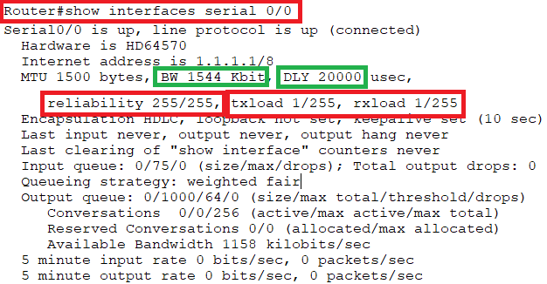

- Can we modify the K Values? How? Give some example scenarios (verbal) which we might need to change these values in production.
- You also said that by default K1 and K3 is ON while other are off. How can we make then ON, what could be the effect or why would we need to make them ON?
- You also did not discuss Link State Protocol (OSPF or IS-IS).
- I do not understand the concept of contagious wildcard mask until it is not configured with a used case(s).

Numbered ACLs are identified by a number and have two types shown in the following table.
Standard ACL | Extended ACL
Use numbers from 1-99 and 1300-1999 | Use numbers from 100-199 and 2000-2699
Can block a network, host, and a subnet | We can allow or deny a network, host, subnet, and service
All services are blocked | Selected services can be blocked
Implemented closest to the destination | Implemented closest to the source
Filtering is done based on only source IP address | Filtering is done based on source IP, destination IP, protocol, or Port No.
You said that standard ACL numbers range from 1-99 and extended ACL numbers range from 100-199. But according to an online source, the range is different which is shown in the table above.

Creating the following ACL, It only the incoming traffic should be denied from hosts 192.168.1.1, 192.168.1.2, 192.168.1.3 and should not be able to ping any device network in network 192.168.2.0. While it should allow to ping reversely I.e. from any host in network 192.168.2.0 to hosts 192.168.1.1, 192.168.1.2, and 192.168.1.3. But the communication is stopped from both ways. Why?
ACL LIST:
Standard IP access list 1
10 deny host 192.168.1.1
20 deny host 192.168.1.2
30 deny 192.168.3.0 0.0.0.255
40 permit any
Go to LAB: Standard ACL to read in detail.

PRACTICE THE FOLLOWING LABS MORE AND MORE:
- VTP (VIRTUAL TRUNKING PROTOCOL)
- ETHERCHANNEL
- STATIC ROUTING
- DEFAULT ROUTING

